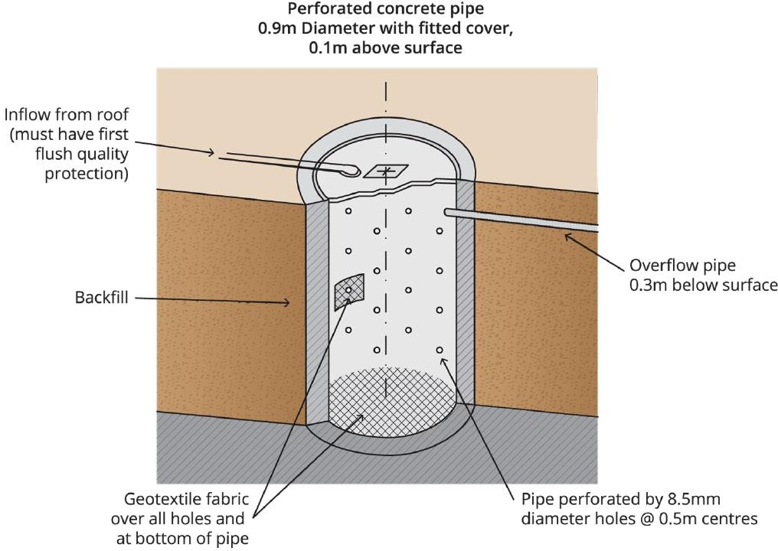

Figure 3. Leaky well infiltration system.

Performance efficiency
Data on the performance efficiency of infiltration systems is presented in the Performance Efficiency section and Table 1 of the Infiltration Basins and Trenches BMP, based on Fletcher et al. (2004).

Cost^
The cost for soakwell systems can vary considerably according to the type of soakwell to be installed, site- specific conditions (including soil type), configuration, location, storage volumes, and landscaping and restoration requirements.
See Chapter 6: Retrofitting, Case Study 7.1 ‘Town of Mosman Park – Total Water Cycle Project’ for further information on the costs of a catchment-wide infiltration project. An example of the techniques used in the Town of Mosman Park to maximise infiltration in the catchment is the installation of combination gully/soakwells, as shown in Figure 2. The cost of installation and materials for each 2.4 m deep soakwell was approximately $1,300 per unit (note : 2004/05 prices) (Glover, M. 2007, pers. comm.2).
Installation and other associated works are a significant proportion of the cost of these systems. Soakwells are a relatively cheap stormwater management measure for lot-scale application.
^The costs quoted in this section are from around 2000 to 2007 and have not been adjusted for inflation or potential cost changes due to technological advances which may have occurred since this chapter was published in 2007. Therefore, it should be considered indicative only and users of the manual are encouraged to seek further specific industry advice on the current costs as appropriate.

2 Personal communication with Martyn Glover, City of Bayswater, 2007.

Design considerations
Design considerations for soakwells are similar to those for other infiltration systems.
Soil type and stability, topography, separation to groundwater, setback to buildings and pre-treatment to remove sediment, litter and other pollutants must all be considered. These issues are discussed in the Design Considerations section of the Infiltration Basins and Trenches BMP.

Design guidelines
The calculations contained in this section for sizing the storage volume of soakwells and determining emptying time are based on Engineers Australia (2006) and Argue (2004). The calculations should be applied with caution to the sizing of infiltration systems where shallow groundwater is present. This approach does not consider the impacts of shallow groundwater in its calculation, which may reduce infiltration capacity. Detailed modelling of shallow groundwater table situations is recommended. Designers should take into account the maximum groundwater level, and hence the minimum infiltration potential, in determining their flood detention design. However, designers should also consider maximum infiltration opportunities to achieve aquifer recharge when the groundwater table is below its maximum level (refer to the Design Considerations section of the Infiltration Basins and Trenches BMP for further discussion).
Inflow volume
The required storage volume is defined by the difference in inflow and outflow volumes for the duration of a storm. The inflow volume is a product of the rainfall, runoff coefficient and contributing area connected to the infiltration system, i.e.:
𝐶𝑖𝐴𝐷

𝐹𝑙𝑜𝑤 𝑉𝑜𝑙𝑢𝑚𝑒 =

Where:

1000

C = runoff coefficient
i = probabilistic rainfall intensity (mm/hr)
A = contributing area connected to the infiltration system (m2) D = storm duration (hours)
Soakwell sizing
Note that the following equation is based on an approximation where d ≈ H and may not be valid for other design situations.
Argue (2004) provides the following formula for sizing of a soakwell:

∀
𝑑 = √ 𝜋
4 (𝐻 + 120𝑘ℎ𝑡𝑈
(refer to Argue 2004 for derivation) Where:
𝑑 = 𝑤𝑒𝑙𝑙 𝑑𝑖𝑎𝑚𝑒𝑡𝑒𝑟 (𝑚)
∀ = 𝐼𝑛𝑓𝑙𝑜𝑤 𝑣𝑜𝑙𝑢𝑚𝑒 (𝑚³)
𝐻 = 𝑤𝑒𝑙𝑙 ℎ𝑒𝑖𝑔ℎ𝑡 (𝑚)

𝑘ℎ = 𝑠𝑜𝑖𝑙 𝑠𝑎𝑡𝑢𝑟𝑎𝑡𝑒𝑑 ℎ𝑦𝑑𝑟𝑎𝑢𝑙𝑖𝑐 𝑐𝑜𝑛𝑑𝑢𝑐𝑡𝑖𝑣𝑖𝑡𝑦 (𝑚𝑠⁻¹)
𝜏 = 𝑡𝑖𝑚𝑒 𝑏𝑎𝑠𝑒 𝑜𝑓 𝑡ℎ𝑒 𝑑𝑒𝑠𝑖𝑔𝑛 𝑠𝑡𝑜𝑟𝑚 𝑟𝑢𝑛𝑜𝑓𝑓 ℎ𝑦𝑑𝑟𝑜𝑔𝑟𝑎𝑝ℎ (𝑚𝑖𝑛)
𝑈 = 𝑠𝑜𝑖𝑙 𝑚𝑜𝑑𝑒𝑟𝑎𝑡𝑖𝑜𝑛 𝑓𝑎𝑐𝑡𝑜𝑟 (𝑇𝑎𝑏𝑙𝑒 3 𝑖𝑛 𝑡ℎ𝑒 𝐼𝑛𝑓𝑖𝑙𝑡𝑟𝑎𝑡𝑖𝑜𝑛 𝐵𝑎𝑠𝑖𝑛𝑠 𝑎𝑛𝑑 𝑇𝑟𝑒𝑛𝑐ℎ𝑒𝑠 𝐵𝑀𝑃)
The above equation assumes the device is empty at the commencement of flow. Application of this equation must be followed by a check on the emptying time of the system’s storage.
Emptying time
Emptying time is defined as the time taken to completely empty a storage associated with an infiltration system following the cessation of rainfall. This is an important design consideration as the computation procedures previously described assume that the storage is empty prior to the commencement of the design storm event.
Argue (2004) provides the following formula for calculating the emptying time for soakwells:
𝑑

4.6𝑑
𝑇 = − (
4𝑘
) 𝑙𝑜𝑔10 (

4 )
𝑑

ℎ 𝐻 + (4)
(refer to Argue 2004 for derivation)
𝑇 = 𝑒𝑚𝑝𝑡𝑦𝑖𝑛𝑔 𝑡𝑖𝑚𝑒 (𝑠)
𝑑 = 𝑤𝑒𝑙𝑙 𝑑𝑖𝑎𝑚𝑒𝑡𝑒𝑟 (𝑚)
𝐻 = 𝑤𝑒𝑙𝑙 ℎ𝑒𝑖𝑔ℎ𝑡 (𝑚)
𝑘ℎ = 𝑠𝑜𝑖𝑙 𝑠𝑎𝑡𝑢𝑟𝑎𝑡𝑒𝑑 ℎ𝑦𝑑𝑟𝑎𝑢𝑙𝑖𝑐 𝑐𝑜𝑛𝑑𝑢𝑐𝑡𝑖𝑣𝑖𝑡𝑦 (𝑚𝑠⁻¹)
Further discussion regarding emptying times is contained in the Design Guidelines section of the Infiltration Basins and Trenches BMP.

Maintenance
Soakwells require maintenance for efficient operation and to reduce the risk of mosquito breeding, including regular inspection and cleaning to prevent clogging by sediments and litter. Pre-treatment BMPs can significantly reduce the maintenance requirements by preventing sediments and litter from entering the system. To prevent road/carpark soakwells from being clogged with sediment/litter during road and housing/building construction (see Figure 4), temporary bunding or sediment controls need to be installed (see Figure 5 for an example of a sediment fence). See section 2.1.1 ‘Land development and construction sites’ of Chapter 7 for information about site management practices.
A maintenance plan for infiltration systems is described in the Maintenance section of the Infiltration Basins and Trenches BMP.

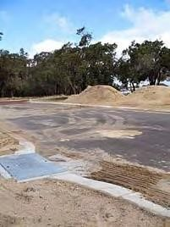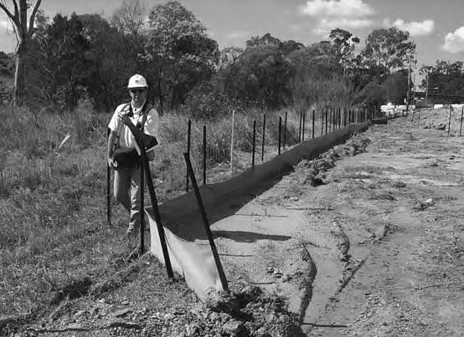

Figure 4. Soil entering a side entry pit that has a soakwell at the base; located within a pipeless subdivision within the City of Mandurah, WA. (Photograph: Department of Water 2007.)
Figure 5. Silt fence for controlling sediment during land development. (Photograph: André Taylor, Ecological Engineering Pty Ltd.)

Worked example
Caution: The following worked examples use Rational Method as per the Australian Rainfall and Runoff (ARR) Book VIII (Institution of Engineers, Australia 2001). However, as per the updated ARR Book 9 ‘Runoff in Urban Areas’, the Rational Method is only suitable for lot-scale scale catchments or simplistic small catchments where flood routing is not critical. This method is not suitable for a ‘precinct’ scale estimation of peak flows as it has ‘limited’ runoff generation and surface routing capabilities. If runoff volume management infrastructure forms part of a solution, or if an understanding of potential impacts on downstream flooding are required, then a ‘strong’ hydrologic estimation method such as a runoff-routing model should be used (ARR 2019). For further information on the limitations of Rational Method, please refer to Book 9 ‘Runoff in Urban Areas’ of ARR 2019.
The following worked example is based on a WSUD Workshop held by John Argue in Perth, November 2005.
An onsite stormwater retention system is to be designed for runoff from a roof located in Perth. The site is located in an elevated area with good clearance to groundwater, hence application of the formulae contained in the design guideline for this BMP is considered appropriate.
The design parameters are listed below:
𝑅𝑜𝑜𝑓 𝑎𝑟𝑒𝑎, 𝐴 = 400 𝑚𝑆𝑜𝑖𝑙 𝑠𝑎𝑡𝑢𝑟𝑎𝑡𝑒𝑑 ℎ𝑦𝑑𝑟𝑎𝑢𝑙𝑖𝑐 𝑐𝑜𝑛𝑑𝑢𝑐𝑡𝑖𝑣𝑖𝑡𝑦, 𝑘ℎ = 1.6 × 10 − 4 𝑚𝑠²
⁻¹ (𝑠𝑎𝑛𝑑𝑦)
𝑆𝑡𝑎𝑛𝑑𝑎𝑟𝑑 𝑠𝑜𝑎𝑘𝑤𝑒𝑙𝑙 𝑒𝑓𝑓𝑒𝑐𝑡𝑖𝑣𝑒 ℎ𝑒𝑖𝑔ℎ𝑡, 𝐻 = 2.30 𝑚
Based on spreadsheet analysis, for a required design average recurrence interval (ARI) of two years (or 0.5 EY), refer Engineers Australia (2006) for methods of ‘t’ calculation:
𝑠𝑖𝑡𝑒 𝑡𝑐 = 15 𝑚𝑖𝑛𝑢𝑡𝑒𝑠 (𝑐𝑎𝑙𝑐𝑢𝑙𝑎𝑡𝑒𝑑 𝑠𝑖𝑡𝑒 𝑡𝑖𝑚𝑒 𝑜𝑓 𝑐𝑜𝑛𝑐𝑒𝑛𝑡𝑟𝑎𝑡𝑖𝑜𝑛)
𝑠𝑖𝑡𝑒 𝑡 = 30 𝑚𝑖𝑛𝑢𝑡𝑒𝑠 (𝑐𝑎𝑙𝑐𝑢𝑙𝑎𝑡𝑒𝑑 𝑠𝑖𝑡𝑒 𝑡𝑖𝑚𝑒 𝑜𝑓 𝑐𝑜𝑛𝑐𝑒𝑛𝑡𝑟𝑎𝑡𝑖𝑜𝑛)

𝜏 = 15 + 30
= 45 𝑚𝑖𝑛𝑢𝑡𝑒𝑠 (𝑡𝑖𝑚𝑒 𝑏𝑎𝑠𝑒 𝑜𝑓 𝑡ℎ𝑒 𝑑𝑒𝑠𝑖𝑔𝑛 𝑠𝑡𝑜𝑟𝑚 𝑟𝑢𝑛𝑜𝑓𝑓 ℎ𝑦𝑑𝑟𝑜𝑔𝑟𝑎𝑝ℎ 𝑖𝑛 𝐹𝑖𝑔𝑢𝑟𝑒 3)
Based on the above, the design rainfall intensity i2 = 31.7 mm/hr (refer to Rainfall Intensity–Frequency– Duration curves for Perth, available from Bureau of Meteorology).
Runoff volume

𝐼𝑛𝑓𝑙𝑜𝑤 𝑉𝑜𝑙𝑢𝑚𝑒 ∀=
𝐶𝑖𝐴𝐷 1000

From ARR Book VIII (Institution of Engineers Australia 2001):
𝐶𝑦 = 𝐹𝑦. 𝐶10
Where:
𝐶𝑦 = 𝑟𝑢𝑛𝑜𝑓𝑓 𝑐𝑜𝑒𝑓𝑓𝑖𝑐𝑖𝑒𝑛𝑡 𝑓𝑜𝑟 𝑎 ‘𝑌’ 𝑦𝑒𝑎𝑟 𝐴𝑅𝐼 (𝑐𝑢𝑟𝑟𝑒𝑛𝑡𝑙𝑦 𝑡𝑒𝑟𝑚𝑒𝑑 𝑎𝑠 𝐸𝑌 𝑜𝑟 𝐴𝐸𝑃)
𝐹𝑦 = 𝑓𝑟𝑒𝑞𝑢𝑒𝑛𝑐𝑦 𝑓𝑎𝑐𝑡𝑜𝑟 𝑓𝑜𝑟 𝑟𝑎𝑡𝑖𝑜𝑛𝑎𝑙 𝑚𝑒𝑡ℎ𝑜𝑑 𝑟𝑢𝑛𝑜𝑓𝑓 𝑐𝑜𝑒𝑓𝑓𝑖𝑐𝑖𝑒𝑛𝑡𝑠
𝐶10 = 10 𝑦𝑒𝑎𝑟 𝐴𝑅𝐼 (𝑜𝑟 10% 𝐴𝐸𝑃) 𝑟𝑢𝑛𝑜𝑓𝑓 𝑐𝑜𝑒𝑓𝑓𝑖𝑐𝑖𝑒𝑛𝑡 (0.9 𝑤ℎ𝑒𝑟𝑒 𝑡ℎ𝑒 𝑓𝑟𝑎𝑐𝑡𝑖𝑜𝑛 𝑖𝑚𝑝𝑒𝑟𝑣𝑖𝑜𝑢𝑠 𝑖𝑠 1)
Therefore, for ARI = 2 years or (0.5 EY):
𝐶2 = 𝐹2. 𝐶10
𝐶2 = 0.85 ∗ 0.90
𝐶2 = 0.765
𝐼𝑛𝑓𝑙𝑜𝑤 𝑉𝑜𝑙𝑢𝑚𝑒 ∀= 0.765 ∗ 31.7 (𝑚ℎ𝑟⁻¹) ∗ 400(𝑚²) ∗ 30

∀= 4.85 (𝑚³)
Soakwell sizing
1000
60(ℎ𝑟)

Argue (2004) provides the following formula for sizing of a soakwell:

∀
𝑑 = √ 𝜋
4 (𝐻 + 120𝑘ℎ𝑡𝑈
(refer to Argue 2004 for derivation) Where:
𝑑 = 𝑤𝑒𝑙𝑙 𝑑𝑖𝑎𝑚𝑒𝑡𝑒𝑟 (𝑚)
∀ = 𝐼𝑛𝑓𝑙𝑜𝑤 𝑣𝑜𝑙𝑢𝑚𝑒 (𝑚³)
𝐻 = 𝑤𝑒𝑙𝑙 ℎ𝑒𝑖𝑔ℎ𝑡 (𝑚)
𝑘ℎ = 𝑠𝑜𝑖𝑙 𝑠𝑎𝑡𝑢𝑟𝑎𝑡𝑒𝑑 ℎ𝑦𝑑𝑟𝑎𝑢𝑙𝑖𝑐 𝑐𝑜𝑛𝑑𝑢𝑐𝑡𝑖𝑣𝑖𝑡𝑦 (𝑚𝑠⁻¹)
𝜏 = 𝑡𝑖𝑚𝑒 𝑏𝑎𝑠𝑒 𝑜𝑓 𝑡ℎ𝑒 𝑑𝑒𝑠𝑖𝑔𝑛 𝑠𝑡𝑜𝑟𝑚 𝑟𝑢𝑛𝑜𝑓𝑓 ℎ𝑦𝑑𝑟𝑜𝑔𝑟𝑎𝑝ℎ (𝑚𝑖𝑛)
𝑈 = 𝑠𝑜𝑖𝑙 𝑚𝑜𝑑𝑒𝑟𝑎𝑡𝑖𝑜𝑛 𝑓𝑎𝑐𝑡𝑜𝑟 (𝑇𝑎𝑏𝑙𝑒 3 𝑖𝑛 𝑡ℎ𝑒 𝐼𝑛𝑓𝑖𝑙𝑡𝑟𝑎𝑡𝑖𝑜𝑛 𝐵𝑎𝑠𝑖𝑛𝑠 𝑎𝑛𝑑 𝑇𝑟𝑒𝑛𝑐ℎ𝑒𝑠 𝐵𝑀𝑃)
Where U = 0.5 for sandy soils.

4.85
𝑑 = √ 𝜋 (2.3 + 120 ∗ 1.6 ∗ 10−4 ∗ 45 ∗ 0.5)
4

𝑑 = 1.50 𝑚
Emptying time
Determine the emptying time (T):
𝑑
4.6𝑑 4

𝑇 = − (
4𝑘ℎ
) 𝑙𝑜𝑔10 (
𝑑 )
𝐻 + (4)

𝑇 = −10781 ∗ −0.8533
𝑇 = 9199 𝑠𝑒𝑐𝑜𝑛𝑑𝑠
𝑇 = 2 ℎ𝑜𝑢𝑟𝑠 33 𝑚𝑖𝑛𝑢𝑡𝑒𝑠
The acceptable maximum emptying time for a two year ARI event (0.5 EY event) is one day (Table 5) of the Infiltration Basins and Trenches BMP), therefore the soakwell design is suitable.

References and further reading
Argue, J. R. (Editor) 2004, Water Sensitive Urban Design: basic procedures for ‘source control’ of stormwater – a handbook for Australian practice, Urban Water Resources Centre, University of South Australia, Adelaide, South Australia, in collaboration with Stormwater Industry Association and Australian Water Association.
Department of Water and Environment Regulation and Department of Biodiversity, Conservation and Attraction 2021, Retrofitting, Stormwater management manual for Western Australia, Department of Water and Environment Regulation and Department of Biodiversity, Conservation and Attractions, Perth, Western Australia.
Engineers Australia 2006, Australian Runoff Quality – a guide to water sensitive urban design, Wong,
T. H.F. (Editor-in-Chief), Engineers Media, Crows Nest, New South Wales. Available via www.engineersaustralia.org.au/Resource-Centre/Guidelines-and-Practice-notes
Fletcher, T.D., Duncan, H.P., Poelsma, P. and Lloyd, S.D. 2004, Stormwater flow and quality, and the effectiveness of non-proprietary stormwater treatment measures — a review and gap analysis, Cooperative Research Centre for Catchment Hydrology, Melbourne, Victoria.
Ball J, Babister M, Nathan R, Weeks W, Weinmann E, Retallick M and Testoni I (Editors) 2019, Australian Rainfall and Runoff: A Guide to Flood Estimation, Commonwealth of Australia, Barton, Australian Capital Territory.
Taylor, A.C. 2005, Structural Stormwater Quality BMP Cost/Size Relationship Information from the Literature (Version 3), Cooperative Research Centre for Catchment Hydrology, Melbourne, Victoria.

